Q100. Combination Generation with Bounded Sum (Backtracking)
Aim
To generate all combinations of size k from a given set of integers such that the total sum of elements in each combination does not exceed a specified upper bound using the Backtracking technique.

Problem Definition
Input
- A → Set/List of integers
- k → Required size of each combination
- BOUND → Maximum allowed sum
Output
- All valid combinations of size k whose sum is less than or equal to BOUND

Pseudocode
COMBINATION-BOUNDED-SUM(A, k, BOUND)
Input:
A = List of integers
k = Required combination size
BOUND = Maximum allowed sum
Output:
All valid combinations
1. Result ← Empty List
2. FUNCTION BACKTRACK(start, current_combination, current_sum)
3. IF current_sum > BOUND THEN
4. RETURN // Pruning
5. END IF
6. IF length(current_combination) = k THEN
7. ADD current_combination to Result
8. RETURN
9. END IF
10. FOR i ← start TO length(A)-1 DO
11. current_combination.APPEND(A[i])
12. BACKTRACK(
i + 1,
current_combination,
current_sum + A[i]
)
13. current_combination.REMOVE_LAST()
14. END FOR
15. END FUNCTION
16. BACKTRACK(0, Empty List, 0)
17. RETURN Result

Python Program
def bounded_sum_combinations(arr, k, bound):
result = []
def backtrack(start, current_combination, current_sum):
# Pruning condition
if current_sum > bound:
return
# Valid combination found
if len(current_combination) == k:
result.append(current_combination[:])
return
# Explore remaining elements
for i in range(start, len(arr)):
current_combination.append(arr[i])
backtrack(
i + 1,
current_combination,
current_sum + arr[i]
)
current_combination.pop()
backtrack(0, [], 0)
return result
# Driver Code
arr = [2, 3, 5, 7, 8]
k = 3
bound = 15
combinations = bounded_sum_combinations(arr, k, bound)
print("Input Set:", arr)
print("Combination Size (k):", k)
print("Upper Sum Bound:", bound)
print("\nValid Combinations:")
for combo in combinations:
print(combo, " Sum =", sum(combo))

Sample Input
A = [2, 3, 5, 7, 8]
k = 3
BOUND = 15

Sample Output
Input Set: [2, 3, 5, 7, 8]
Combination Size (k): 3
Upper Sum Bound: 15
Valid Combinations:
[2, 3, 5] Sum = 10
[2, 3, 7] Sum = 12
[2, 3, 8] Sum = 13
[2, 5, 7] Sum = 14
[2, 5, 8] Sum = 15

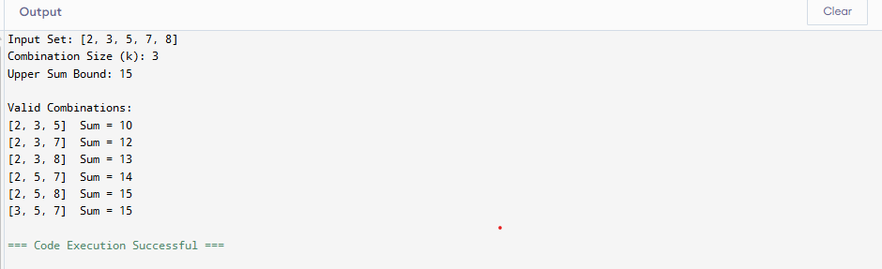
Analysis
Backtracking Strategy
- Recursively build combinations one element at a time.
- Maintain:
  - Current combination
  - Current size
  - Running sum
- Explore all possible choices.
- Backtrack after each recursive call to try alternative elements.
Pruning
The search branch is terminated when:
current_sum > BOUND
Since adding more elements can only increase the sum, no valid solution can exist beyond this point.
Correctness
- Every combination contains exactly k elements.
- Only combinations with sum ≤ BOUND are stored.
- Each element is selected once using increasing indices.
- No duplicate combinations are generated.
- All feasible combinations are explored.

Complexity Analysis
Let:
- n = Number of elements in the set
- k = Required combination size
Time Complexity
O(C(n, k))
where C(n, k) is the number of possible combinations.
Space Complexity
O(k)
for the recursion stack and current combination.

Conclusion
The Backtracking algorithm efficiently generates all combinations of size k whose total sum does not exceed the given bound. By maintaining the running sum and applying pruning whenever the bound is exceeded, the algorithm avoids unnecessary exploration and produces all valid bounded-sum combinations without repetition.

